# Logistic Regression



**Instructions:**

Please share your answers filled in-line in the word document. Submit code separately wherever applicable.

Please ensure you update all the details:

**Name: _____________ Batch ID:** ___________

**Topic: Logistic Regression**

**Hints:**

1. **Business Problem**
   1. **What is the business objective?**
   2. **Are there any constraints?**
2. **Work on each feature of the dataset to create a data dictionary as displayed in the below image:**

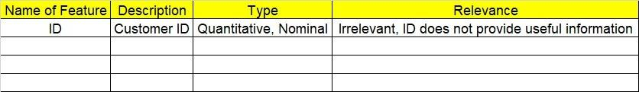

**2.1 Make a table as shown above and provide information about the features such as its data type and its relevance to the model building. And if not relevant, provide reasons and a description of the feature.**

**Using R and Python codes perform:**

1. **Data Pre-processing**

**3.1 Data Cleaning, Feature Engineering, etc.**

**3.2 Outlier Treatment.**

1. **Exploratory Data Analysis (EDA):**
   1. **Summary.**
   2. **Univariate analysis.**
   3. **Bivariate analysis.**
2. **Model Building**
   1. **Build the model on the scaled data (try multiple options).**
   2. **Build a Logistic Regression model.**
   3. **Train and test the model and compare accuracies by building a confusion matrix, plotting ROC and AUC curves.**
   4. **Briefly explain the model output in the documentation.**
3. **Write about the benefits/impact of the solution - in what way does the business (client) benefit from the solution provided?**

Problem Statement: -

1. A psychological study has been conducted by a team of students at a university on married couples to determine the cause of having an extra marital affair. They have surveyed and collected a sample of data on which they would like to do further analysis. Apply Logistic Regression on the data to correctly classify whether a given person will have an affair or not given the set of attributes. Convert the naffairs column to discrete binary type before proceeding with the algorithm.

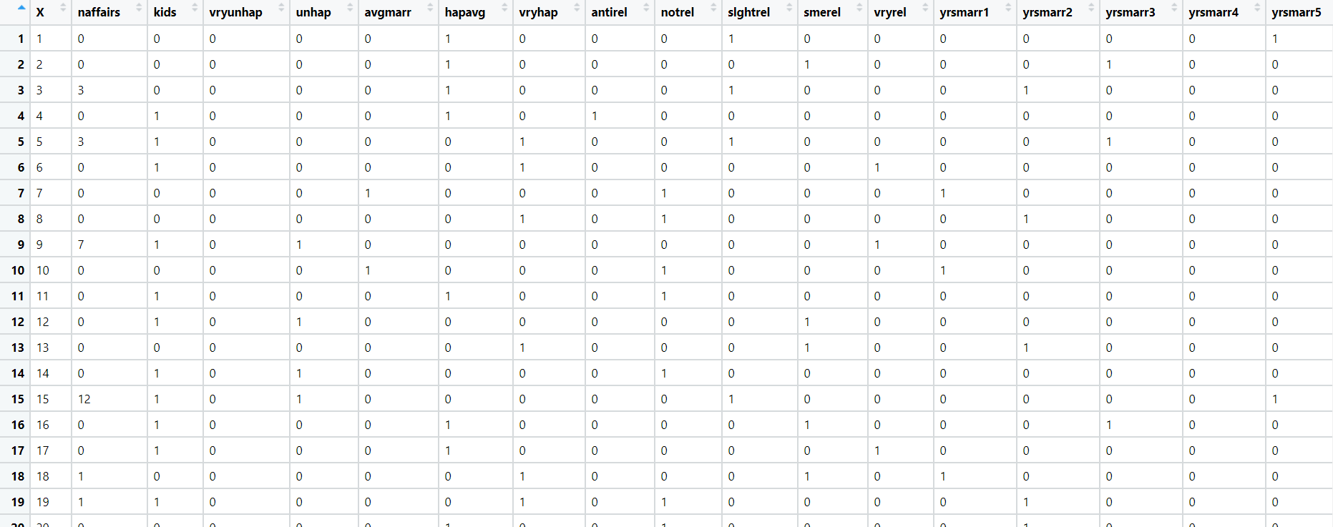

1. In this time and age of widespread internet usage, effective and targeted marketing plays a vital role. A marketing company would like to develop a strategy by analyzing their customer data. For this, data like age, location, time of activity, etc. has been collected to determine whether a user will click on an ad or not. Perform Logistic Regression on the given data to predict whether a user will click on an ad or not.

1. Perform Logistic Regression on the dataset to predict whether a candidate will win or lose the election based on factors like amount of money spent and popularity rank.

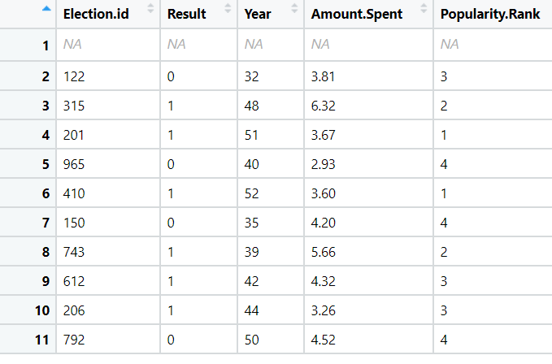

1. It is vital for banks that customers put in long term fixed deposits as they use it to pay interest to customers and it is not viable to ask every customer if they will put in a long-term deposit or not. So, build a Logistic Regression model to predict whether a customer will put in a long-term fixed deposit or not based on the different variables given in the data. The output variable in the dataset is Y which is binary. Snapshot of the dataset is given below.

